1. Launch one ec2 using Amazon Linux 2 image and add script in user data to install Apache.

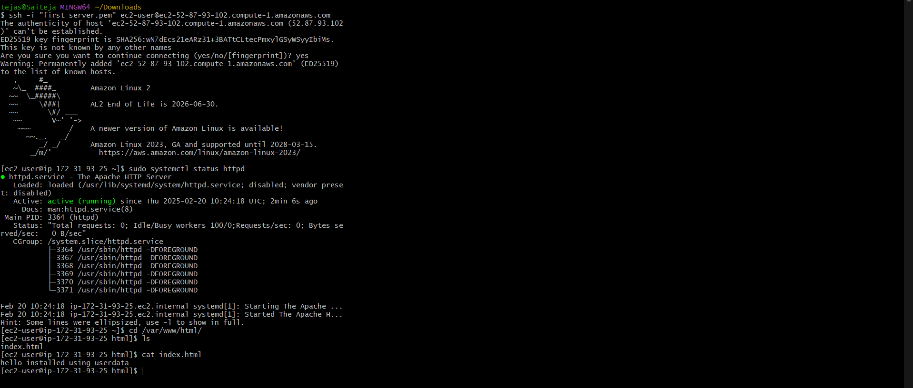

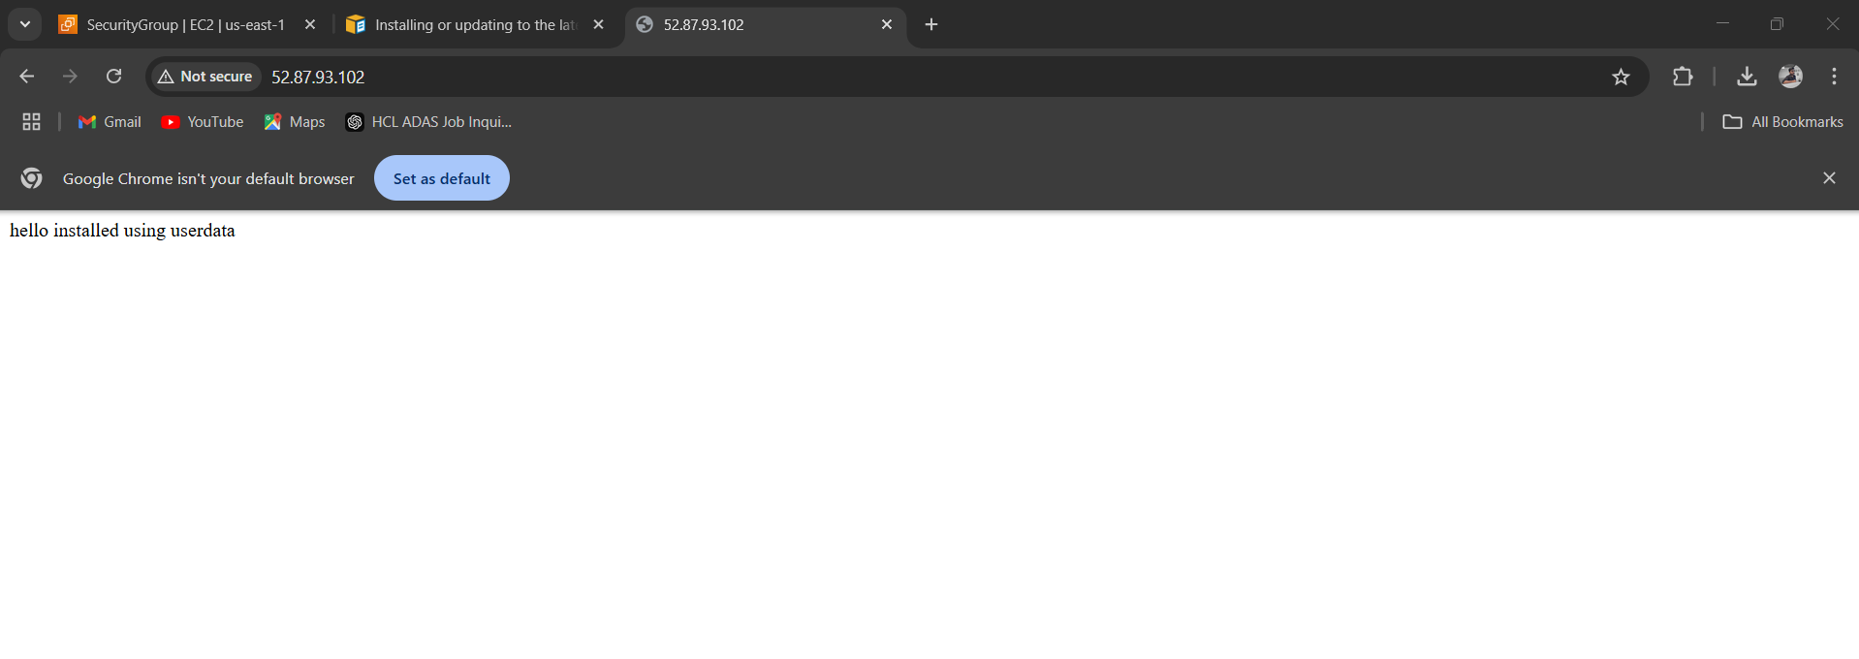

1. Launch one ec2 using Ubuntu image and add script in user data to install Nginx.

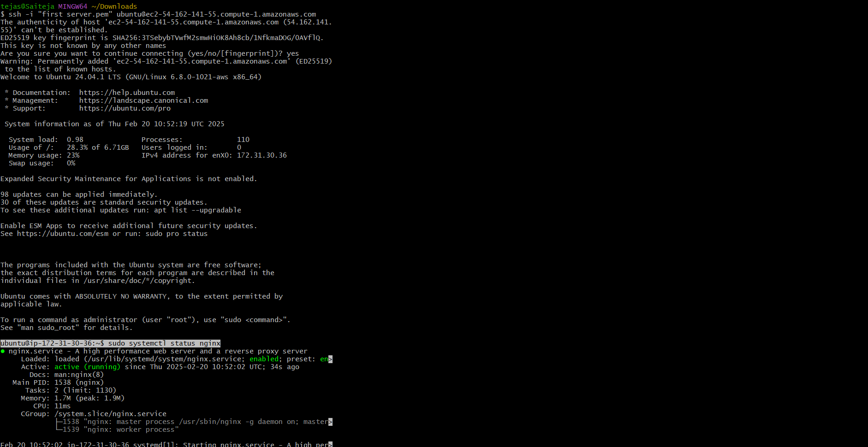

5) Assign password less authentication for ec2 created on Task 2.

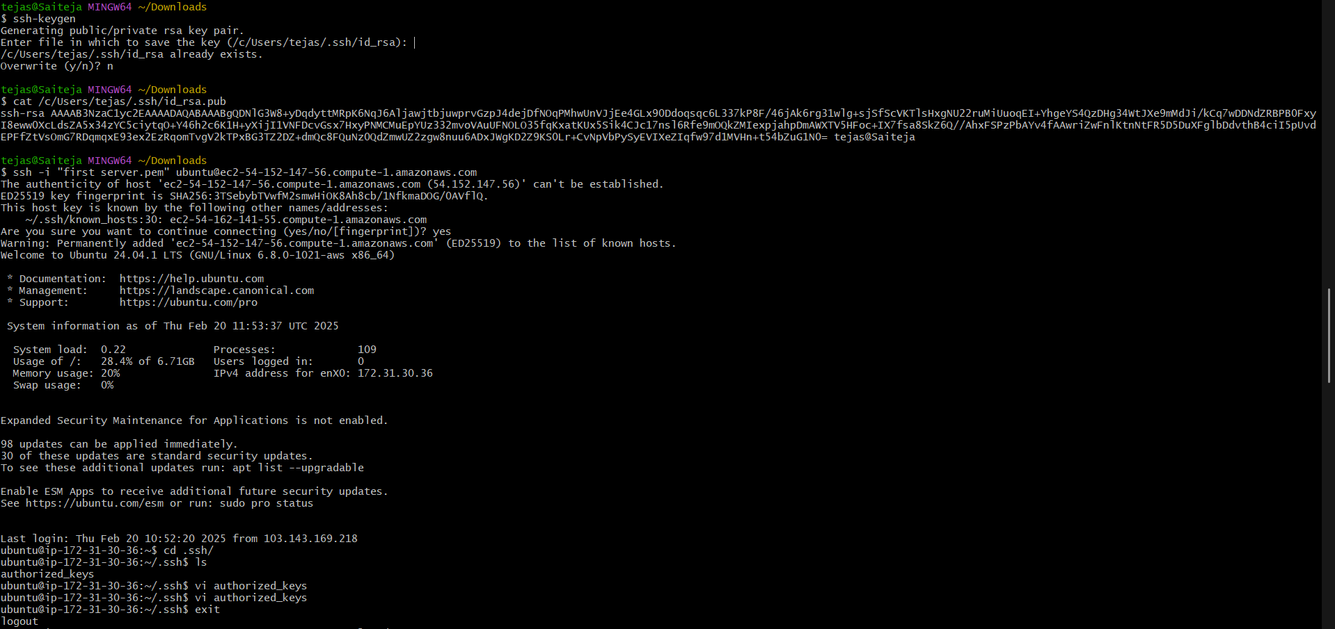

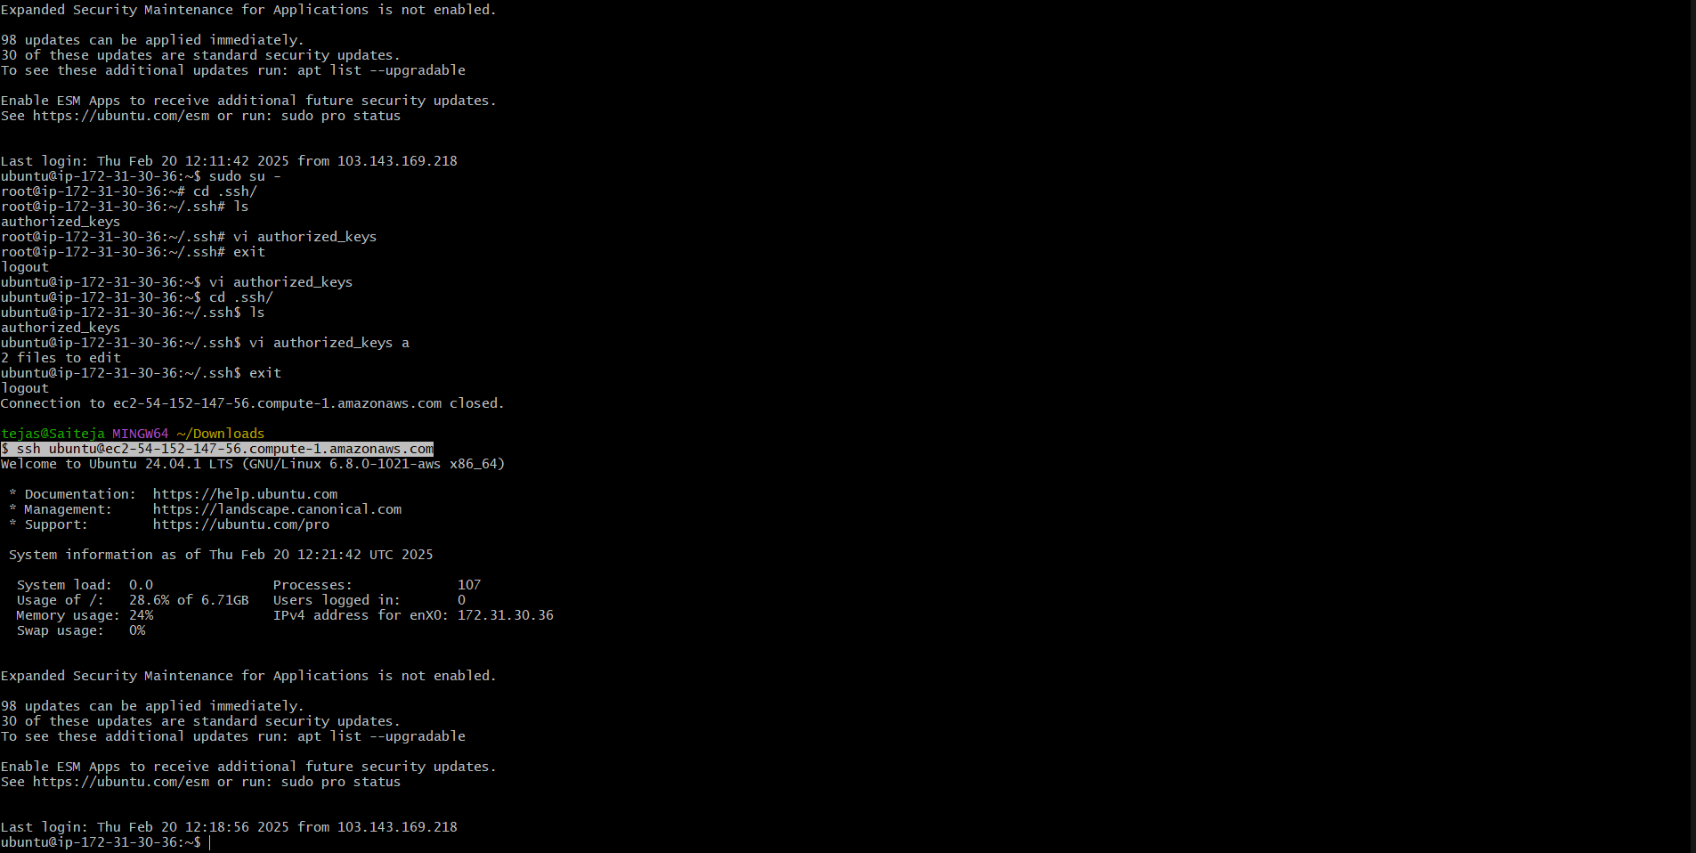

4) Take snapshot of the instane created in Task 1.

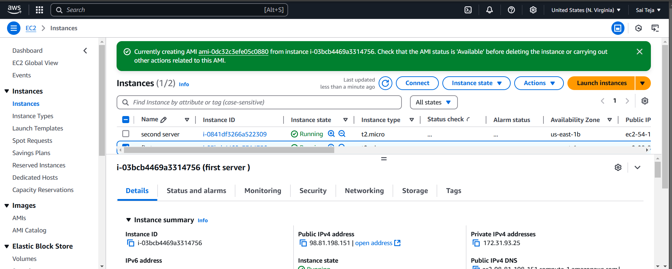

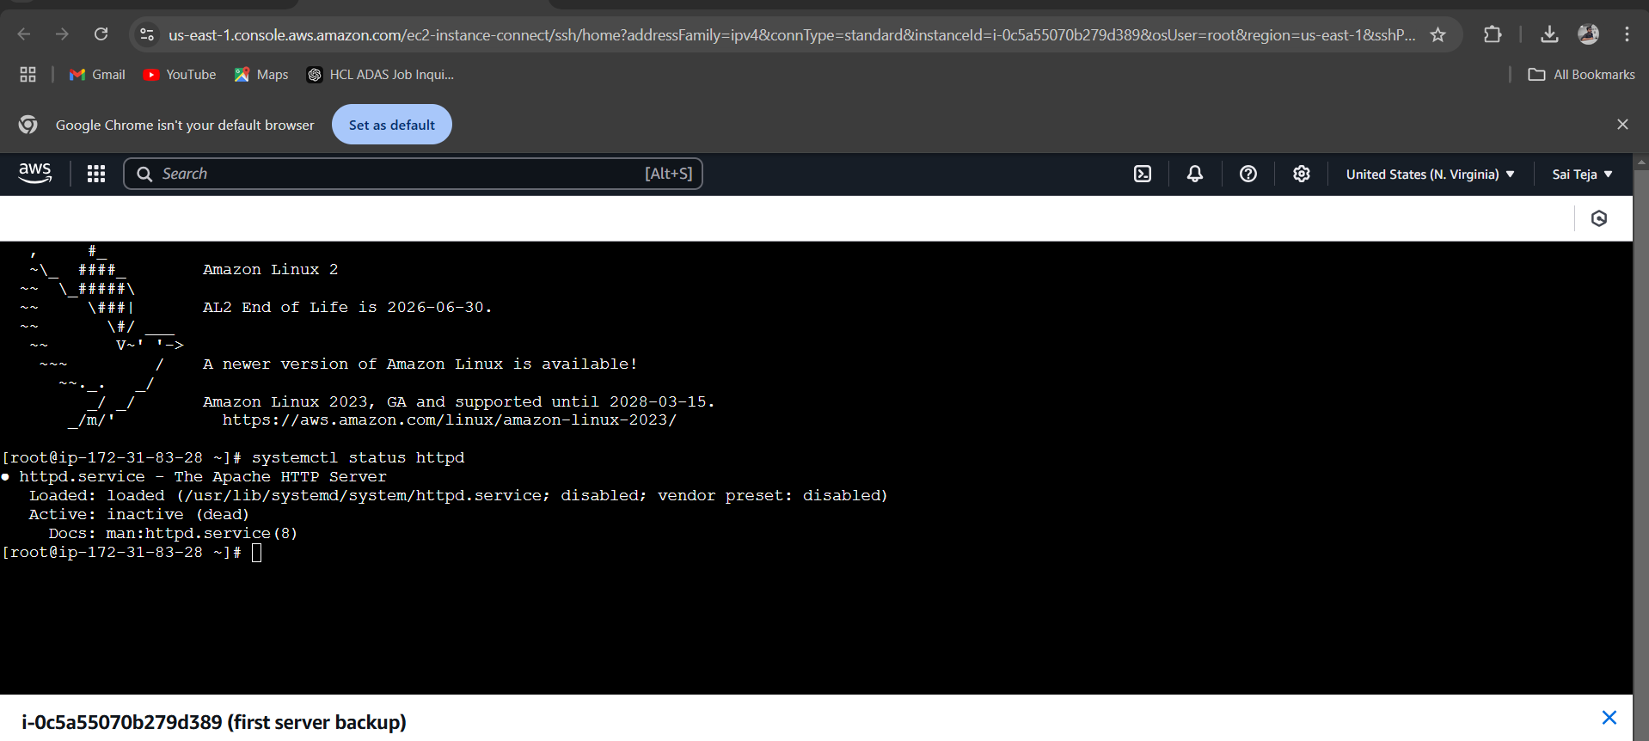

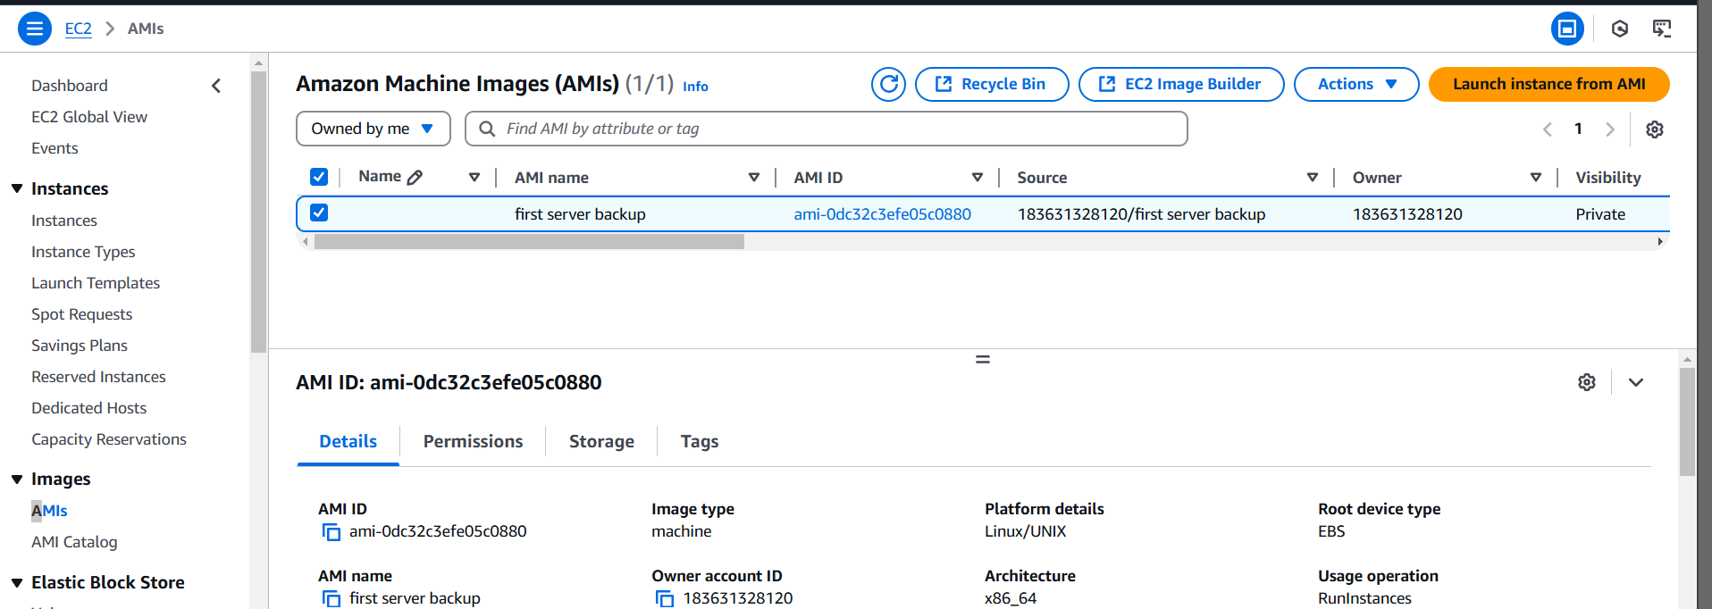

6) Launch any ec2 using spot purchasing option

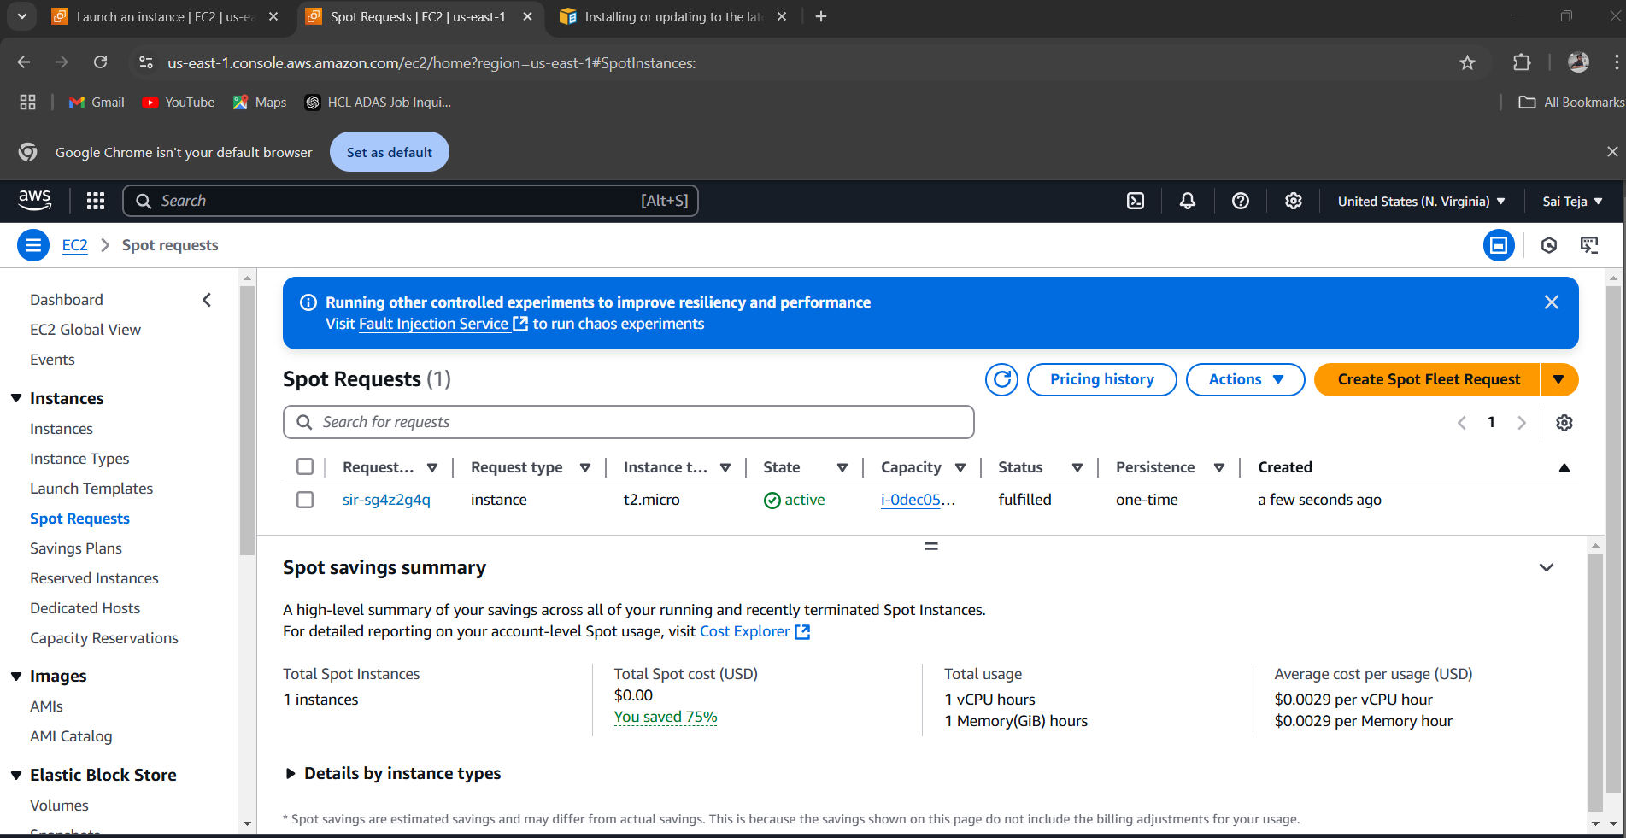

7) Enable Termination policy on ec2 created in Task 2

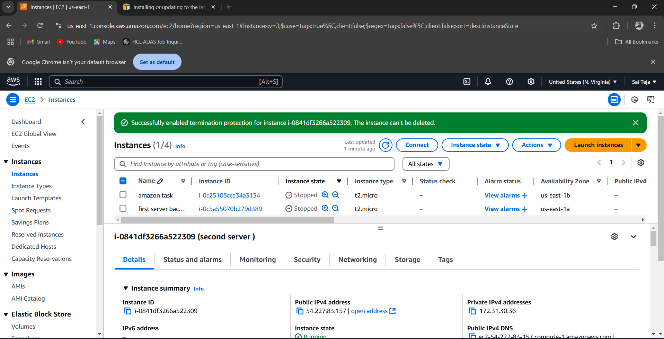

1. Launch one windows server and install tomcat in windows.

--- launch one ec2 instances using window image then connet – RDP client – upload pemkey and generate username and password the remote desktop connection and entre user and password

It will connet to the windows desktop . then download java and tomcat.

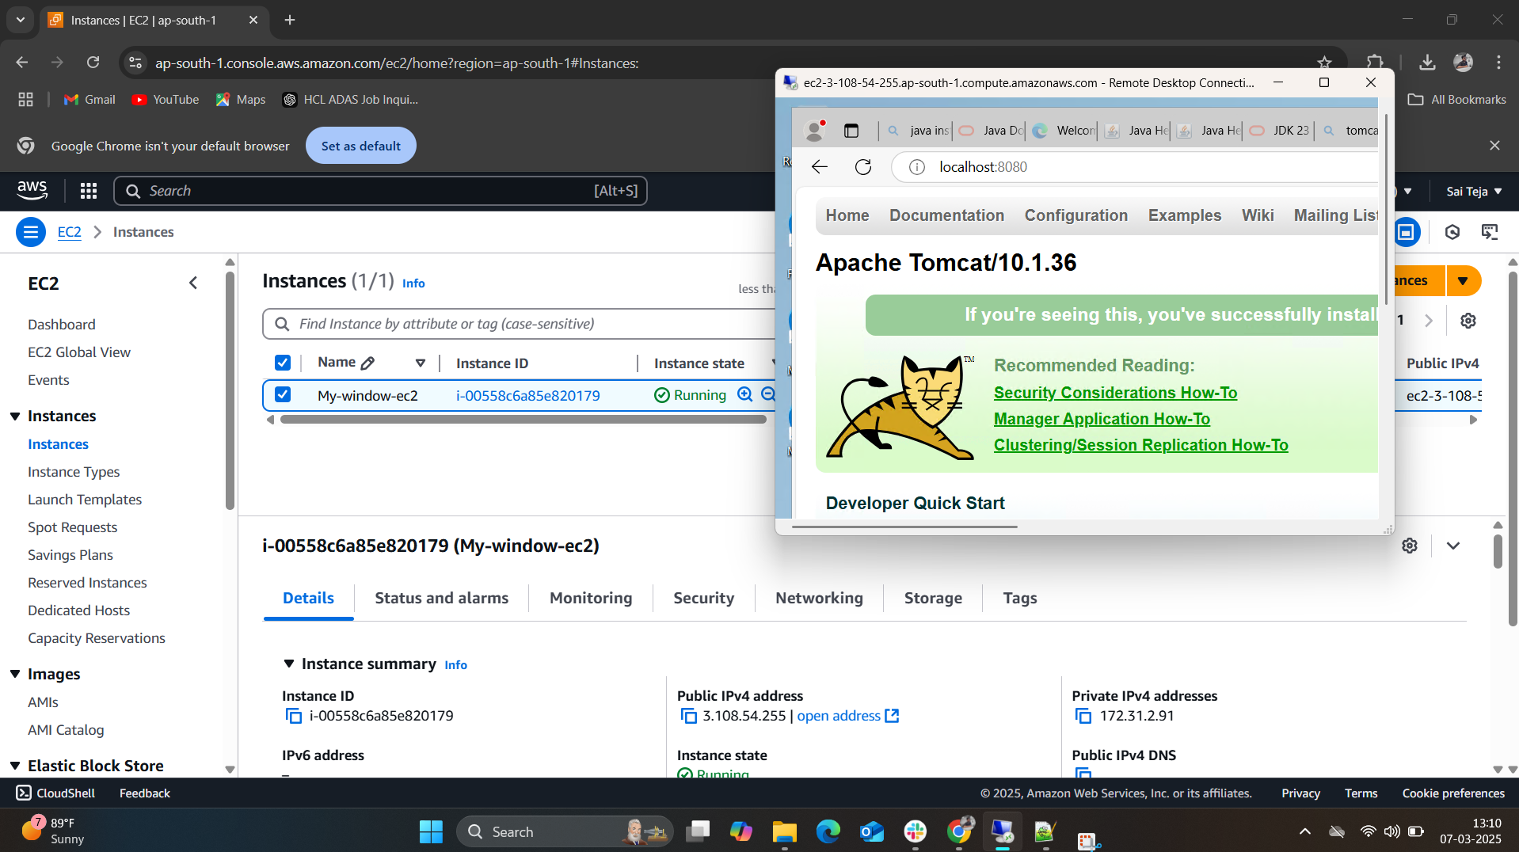

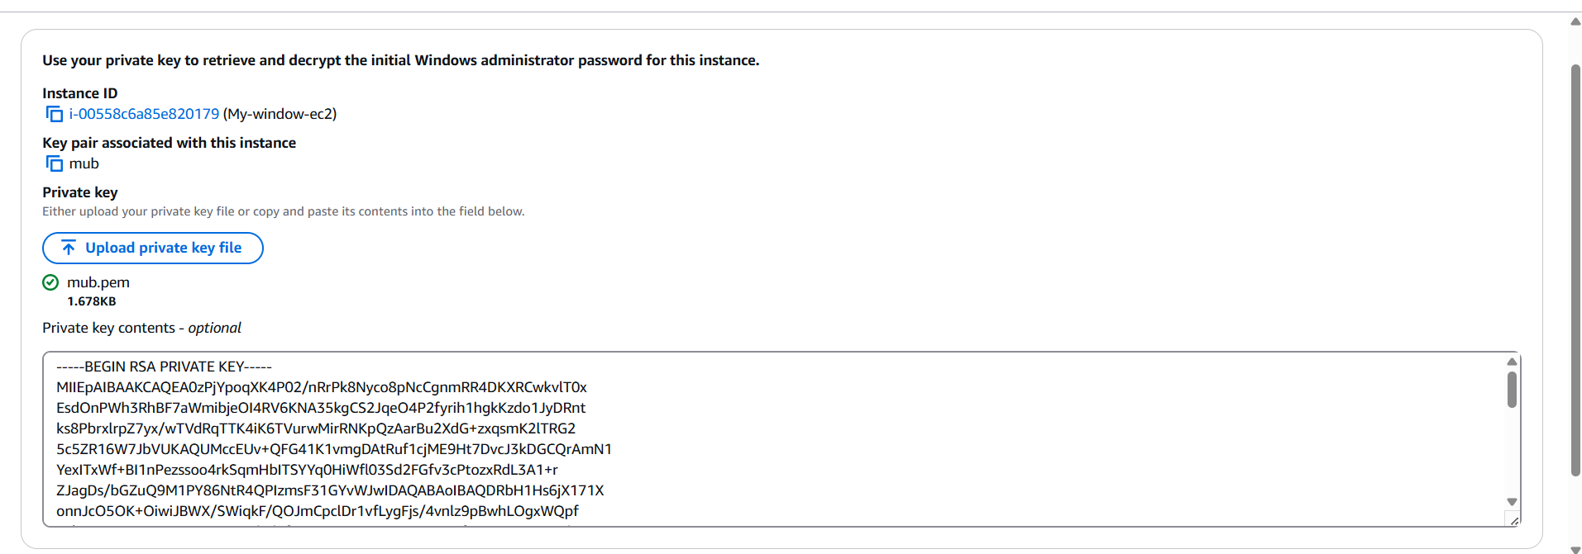

8) Launch one ec2 using Aws CLI.

------using below command we can launch ec2 instances using CLI

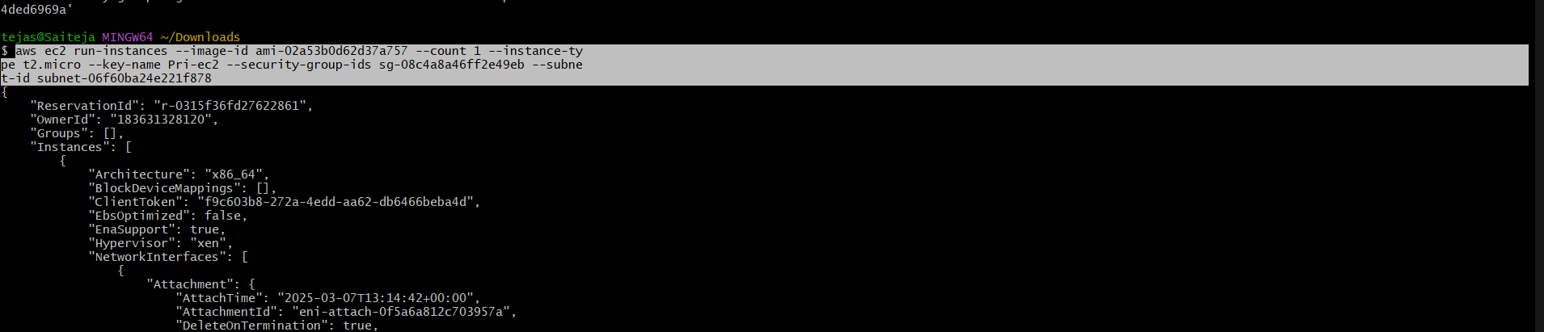

------ In ec2 dashboard we can see one instances has been created

